**Assignment for 28/2**

**Questions:**

**1) Use R to figure out how many elements in the vector below are greater than 2. rooms <- c(1, 5, 2, 3, 1, NA, 3, 1, 3, 2, NA, 1, 8, 3, 1, 4, NA, 1, 3, 1, 2, 1, 7, 1, NA, 4, 3 ,1 ,7 ,2 ,1 ,NA ,1, 1, 3)**

SVAR:

> rooms

[1] 1 5 2 3 1 NA 3 1 3 2 NA 1 8 3 1 4 NA 1 3 1 2 1 7 1

[25] NA 4 3 1 7 2 1 NA 1 1 3

> rooms>2

[1] FALSE TRUE FALSE TRUE FALSE NA TRUE FALSE TRUE FALSE NA FALSE

[13] TRUE TRUE FALSE TRUE NA FALSE TRUE FALSE FALSE FALSE TRUE FALSE

[25] NA TRUE TRUE FALSE TRUE FALSE FALSE NA FALSE FALSE TRUE

> rooms[rooms>2]

[1] 5 3 NA 3 3 NA 8 3 4 NA 3 7 NA 4 3 7 NA 3

> rooms_no_na <- rooms

> is.na(rooms)

[1] FALSE FALSE FALSE FALSE FALSE TRUE FALSE FALSE FALSE FALSE TRUE FALSE

[13] FALSE FALSE FALSE FALSE TRUE FALSE FALSE FALSE FALSE FALSE FALSE FALSE

[25] TRUE FALSE FALSE FALSE FALSE FALSE FALSE TRUE FALSE FALSE FALSE

> !is.na(rooms)

[1] TRUE TRUE TRUE TRUE TRUE FALSE TRUE TRUE TRUE TRUE FALSE TRUE

[13] TRUE TRUE TRUE TRUE FALSE TRUE TRUE TRUE TRUE TRUE TRUE TRUE

[25] FALSE TRUE TRUE TRUE TRUE TRUE TRUE FALSE TRUE TRUE TRUE

> rooms[!is.na(rooms)]

[1] 1 5 2 3 1 3 1 3 2 1 8 3 1 4 1 3 1 2 1 7 1 4 3 1 7 2 1 1 1 3

> rooms_no_na <- rooms[!is.na(rooms)]

> rooms_no_na

[1] 1 5 2 3 1 3 1 3 2 1 8 3 1 4 1 3 1 2 1 7 1 4 3 1 7 2 1 1 1 3

> rooms_no_na>2

[1] FALSE TRUE FALSE TRUE FALSE TRUE FALSE TRUE FALSE FALSE TRUE TRUE

[13] FALSE TRUE FALSE TRUE FALSE FALSE FALSE TRUE FALSE TRUE TRUE FALSE

[25] TRUE FALSE FALSE FALSE FALSE TRUE

> rooms_no_na>2

[1] FALSE TRUE FALSE TRUE FALSE TRUE FALSE TRUE FALSE FALSE TRUE TRUE

[13] FALSE TRUE FALSE TRUE FALSE FALSE FALSE TRUE FALSE TRUE TRUE FALSE

[25] TRUE FALSE FALSE FALSE FALSE TRUE

> rooms_no_na[rooms_no_na>2]

[1] 5 3 3 3 8 3 4 3 7 4 3 7 3

2) Which function tells you the **type of data** the 'rooms' vector above contains?

SVAR:

> class(rooms)

[1] "numeric"

3) What is the result of running the **median**() function on the above 'rooms' vector?

> rooms <- c(1, 5, 2, 3, 1, NA, 3, 1, 3, 2, NA, 1, 8, 3, 1, 4, NA, 1, 3, 1, 2, 1, 7, 1, NA, 4, 3 ,1 ,7 ,2 ,1 ,NA ,1, 1, 3)

> rooms

[1] 1 5 2 3 1 NA 3 1 3 2 NA 1 8 3 1 4 NA 1 3 1 2 1 7 1

[25] NA 4 3 1 7 2 1 NA 1 1 3

> max(rooms)

[1] NA

> max(rooms, na.rm = TRUE)

[1] 8

> mean(rooms, na.rm = TRUE)

[1] 2.566667

4) In order to submit a screenshot of RStudio, do the following first: Inside your R Project (.Rproj), install the 'tidyverse' package and use the download.file() and read_csv() function to read the SAFI_clean.csv dataset into your R project as 'interviews' digital object (see instructions in https://datacarpentry.org/r-socialsci/setup.html and 'Starting with Data' section). Take a screenshot of your RStudio interface showing

a) the line of code you used to create the object 'interviews', incl. the output in the console:

* The code we used to create the object ‘interviews’ is the following: interviews <- read_csv("data/SAFI_clean.csv")

b) the 'interviews' object in the "Environment" top right pane, and

c) the file structure of **your R project** in the bottom right "Files" pane.

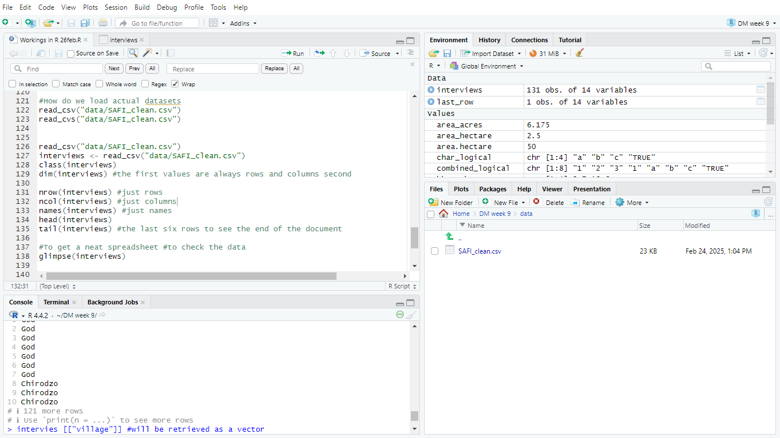

Save the screenshot as a .png image and put it in your **AUID_lastname_firstname** repository inside the class Github organisation (www.github.com/Digital-Methods-HASS) or equivalent. Place here the URL leading to the screenshot in your repository.

https://github.com/Digital-Methods-HASS/au302698_Khalaf_Zaid/tree/main

5) **Challenge**: Tidy up your Danish monarchs dataset (you created last week) sufficiently so that you can load it into R as a tibble using the read_csv() and calculate the mean() and median() duration of their rule over time. Remember you can reload the dataset infinitely and tweak the loading as you discover issues :)

